**DEPARTMENT OF EDUCATION**

**IM GDC SHOPIAN**

Report Writing on Extension Lecture

As a regular feature of the college activities, an extension lecture on the theme “Rashtriya Uchatraya Shiksha Abhiyan” was organised by Department of Education in the Alama Iqbal Block of IM GDC SHOPIAN on 7th June, 2022. The audience comprises the Education students of 5th Semester. The resource person was Prof. Tajamul Islam Seh ,Sr. Assistant Professor Department of Physics ,IM GDC SHOPIAN. Dr. Munir Ahmad Mir, HOD Education extended a warm welcome to the students and resource person and introduced him as an expert in dealing the matters of RUSA in the college.The resource person explained the implementation, monitoring and evaluation of RUSA in a lucid way in his lecture and also highlighted the developmental works under the centrally sponsored scheme in the college in his presentation. In his lecture he also discussed the historical background , objectives, vision and mission, and over all funding procedure of this scheme. His lecture was an interactive one as the quarries raised by the students were answered satisfactorily.

At the end of the lecture Prof. Sheeraz Gull Sheikh briefly touched the important points mentioned by the resource person and also presented Vote of thanks to the worthy principal Prof. Bashir Ahmad Dar for his utmost support, Dr. Munir Ah Mir ,HOD Education for organizing the lecture, the resource person for his valuable experience and expertise and the laudable students of the college.

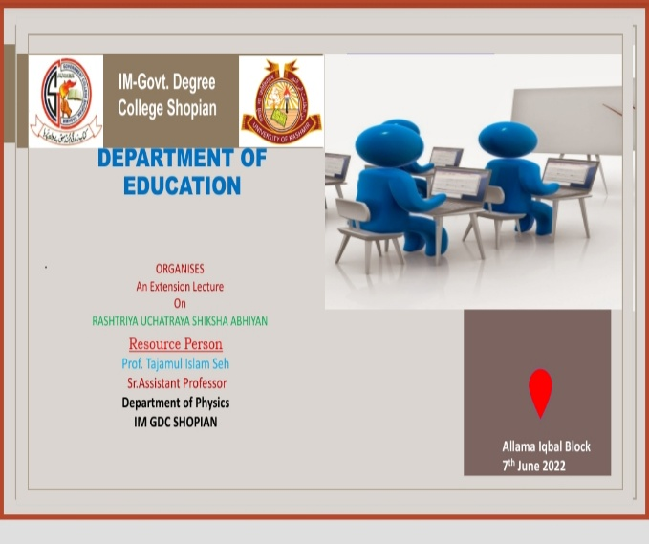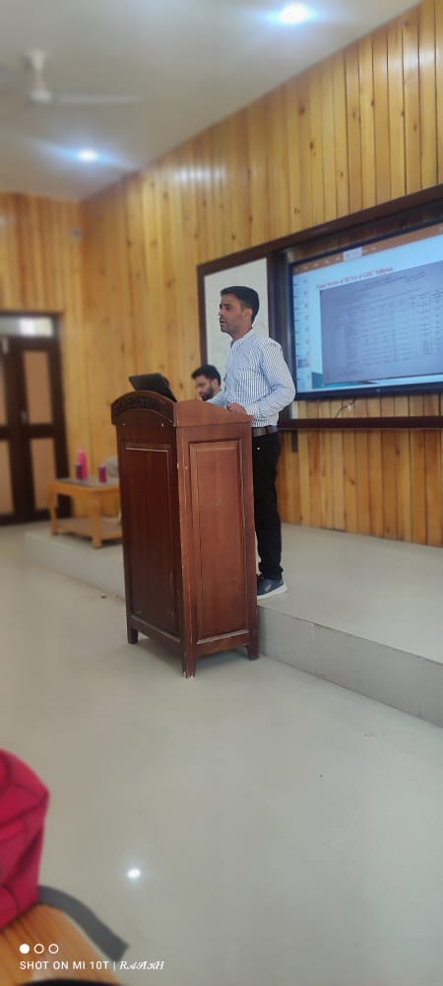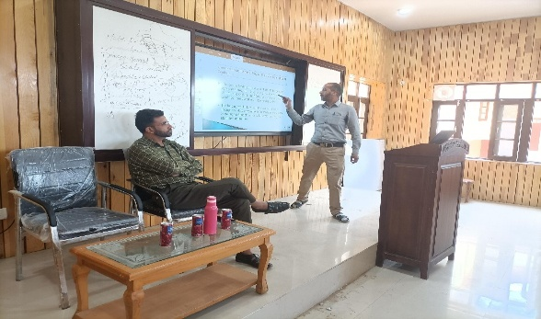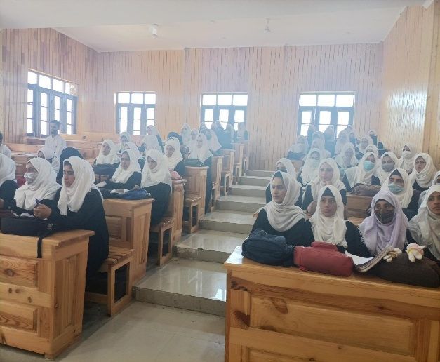 Overall ,the lecture was very informative and students were benefited from it.